**Linux Administration Essentials Assignment Day 8 Solution**

**Assignment 0 :**

**Create a simple shell script to tell the user about their session :**

**Solution :**

[ec2-user@ip-172-31-25-68 ~]$ cat user_session.sh

#!/bin/bash

echo "Your username is : $(whoami)"

echo "current date is : $(date +'%d-%m-%Y')"

echo "current time is : $(date +%r)"

echo "your current working directory is : $(pwd)"

a=$(pwd)

cd $a

num_of_files=$(ls | wc -l)

biggest_file=$(find $a -type f -printf '%s %p\n'| sort -nr | head -1 | cut -d " " -f 2)

echo "number of files present in your current $(pwd) directory is : $num_of_files"

echo "the biggest file in their current $(pwd) directory is : $biggest_file"

[ec2-user@ip-172-31-25-68 ~]$ sh user_session.sh

Your username is : ec2-user

current date is : 12-12-2020

current time is : 05:55:31 PM

your current working directory is : /home/ec2-user

number of files present in your current /home/ec2-user directory is : 8

the biggest file in their current /home/ec2-user directory is : /home/ec2-user/test.img

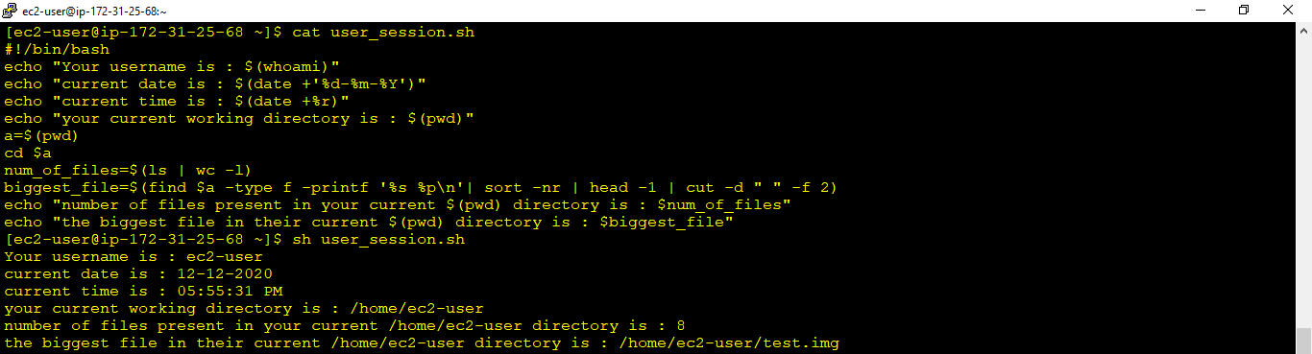

**Assignment 1 :**

Create a directory with a few test files in it (the files can be empty). Now write a script that for every file in that directory you rename it to have an extension of today's date in YYYYMMDD format.

**Solution :**

[ec2-user@ip-172-31-25-68 ~]$ ls -l testdir

total 0

-rw-rw-r-- 1 ec2-user ec2-user 0 Dec 12 18:08 file-1

-rw-rw-r-- 1 ec2-user ec2-user 0 Dec 12 18:08 file-2

-rw-rw-r-- 1 ec2-user ec2-user 0 Dec 12 18:08 file-3

-rw-rw-r-- 1 ec2-user ec2-user 0 Dec 12 18:08 file-4

-rw-rw-r-- 1 ec2-user ec2-user 0 Dec 12 18:08 file-5

[ec2-user@ip-172-31-25-68 ~]$ cat append_date_to_filename.sh

#!/bin/bash

todays_date=$(date '+%Y-%m-%d')

cd testdir

for FILE in *

do

mv $FILE "$FILE.$todays_date"

done

[ec2-user@ip-172-31-25-68 ~]$ sh append_date_to_filename.sh

[ec2-user@ip-172-31-25-68 ~]$ ls -l testdir

total 0

-rw-rw-r-- 1 ec2-user ec2-user 0 Dec 12 18:08 file-1.2020-12-12

-rw-rw-r-- 1 ec2-user ec2-user 0 Dec 12 18:08 file-2.2020-12-12

-rw-rw-r-- 1 ec2-user ec2-user 0 Dec 12 18:08 file-3.2020-12-12

-rw-rw-r-- 1 ec2-user ec2-user 0 Dec 12 18:08 file-4.2020-12-12

-rw-rw-r-- 1 ec2-user ec2-user 0 Dec 12 18:08 file-5.2020-12-12

[ec2-user@ip-172-31-25-68 ~]$

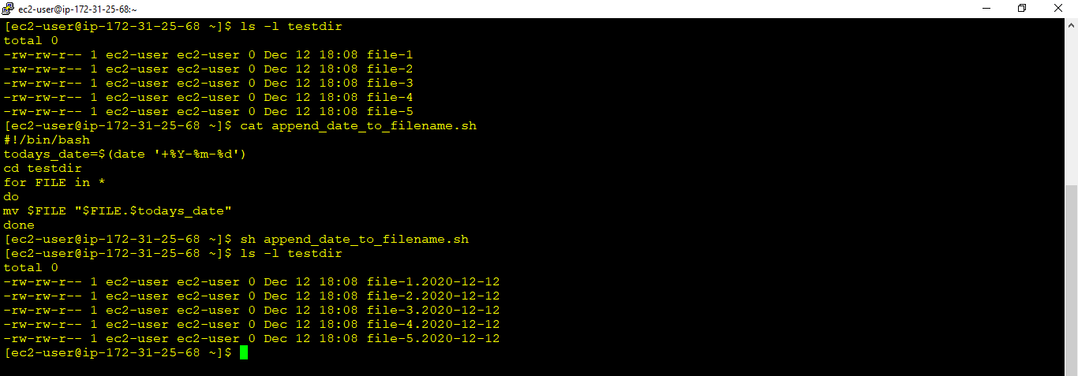

**Assignment 2 :**

Write a script that takes a number as an input and reverses it out to the user. For example, if the original number is 74985, the output should be 58947.

Solu

[ec2-user@ip-172-31-25-68 ~]$ cat reverse_a_number.sh

#!/bin/bash

echo -n "Enter a number to be reversed : "

read n

one_digit=0

rev_digit=""

entered_number=$n

while [ $n -gt 0 ]

do

one_digit=$(( $n % 10 ))

n=$(( $n / 10 ))

rev_digit=$( echo ${rev_digit}${one_digit} )

done

echo "$rev_digit"

[ec2-user@ip-172-31-25-68 ~]$ sh reverse_a_number.sh

Enter a number to be reversed : 74985

58947

[ec2-user@ip-172-31-25-68 ~]$

